|  |  |  |
| --- | --- | --- |
| FSM(Admin) | January 16  2017 | |
|  | | Work Flow Doc. |

# Dashboard

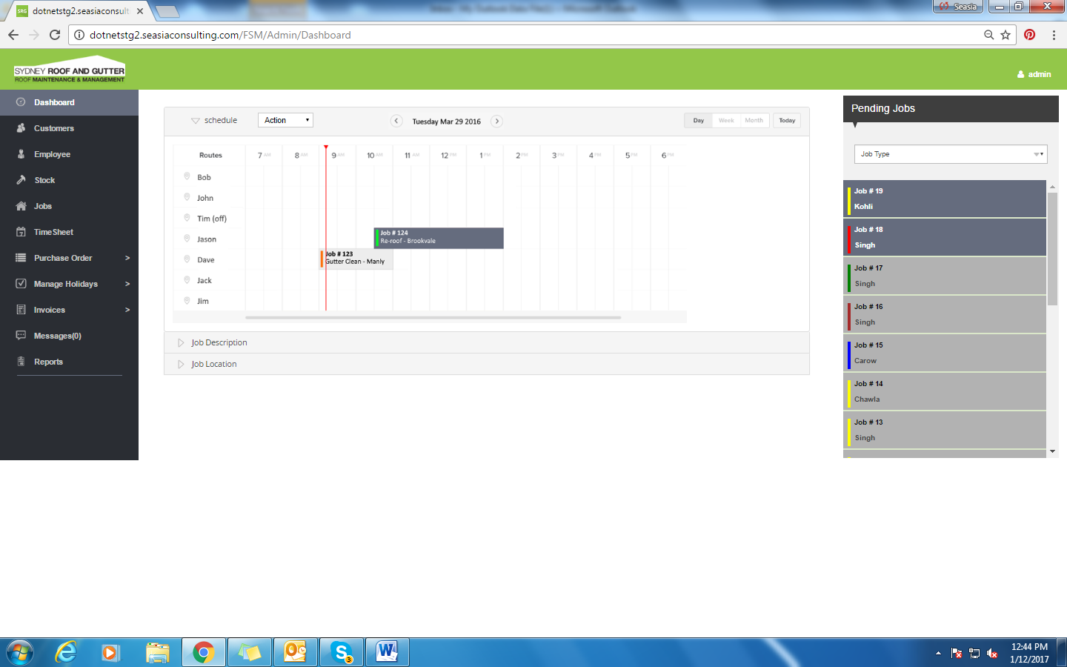

1. We have list of jobs on the right side.
2. User can filter jobs according to job types.
3. Calender with user names and their job details.
4. User can filter calender according to a day, 3 days, week and month.
5. Jobs sites on the map.

## Job Description

On selecting the job from the right navigation menu, job description is displayed as below:

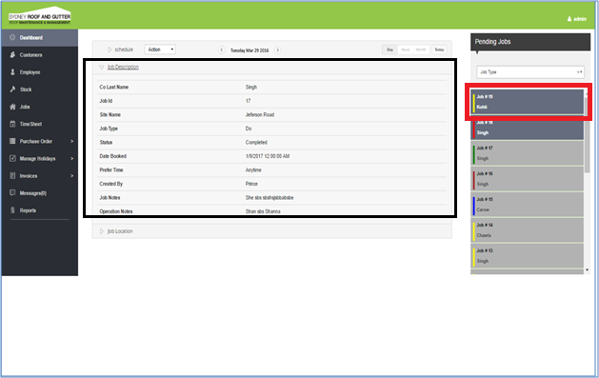

* On click of job, job description will display on the description panel.

## Job Location

The location for the selected job is displayed as below:

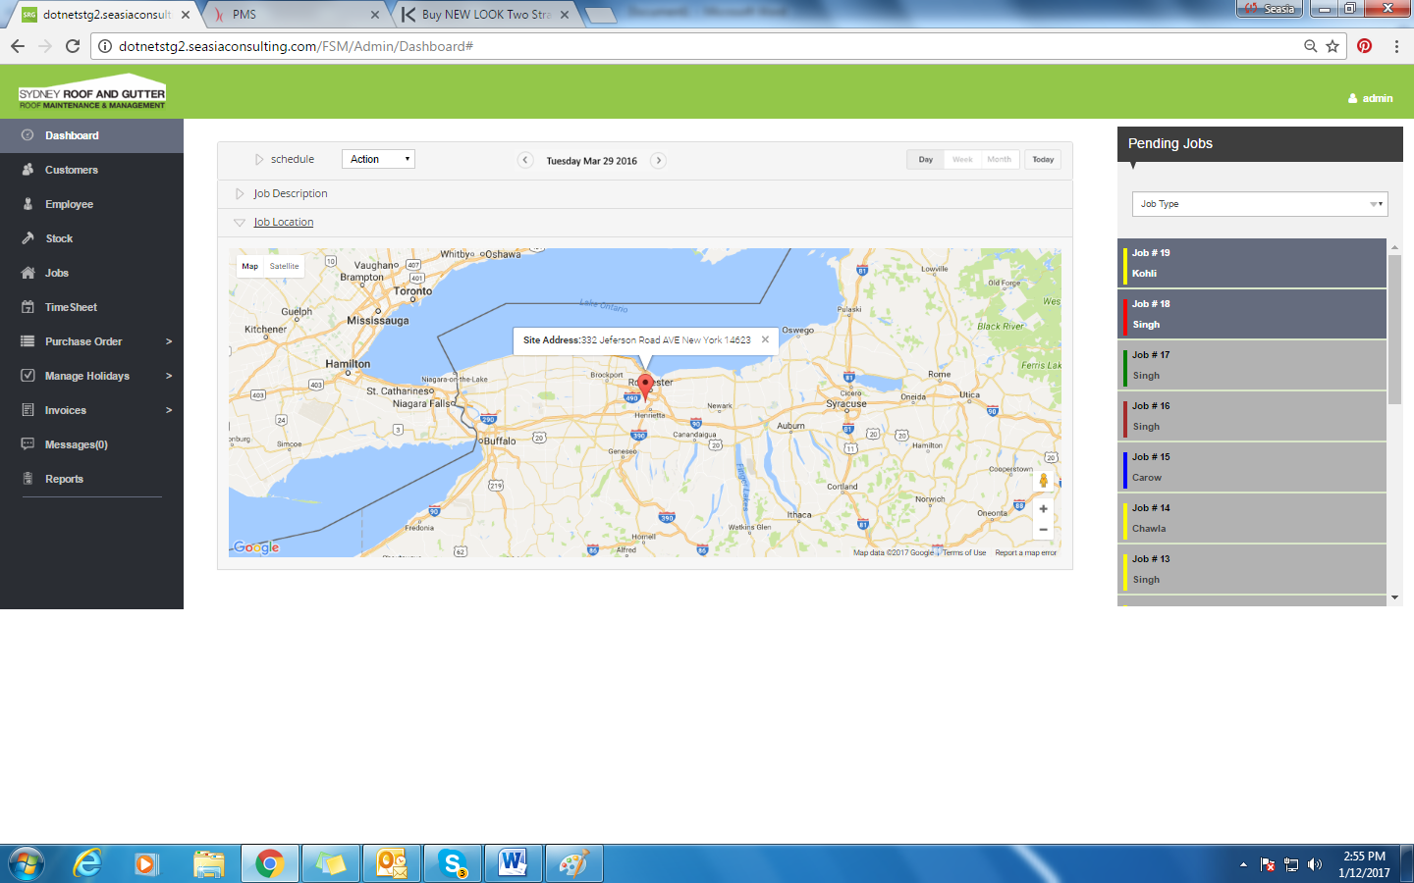

* On click of the location panel, selected job site location will be shown on the map.

# Customer

On clicking the ‘Customer’ option from the side menu, the screen is displayed as below:

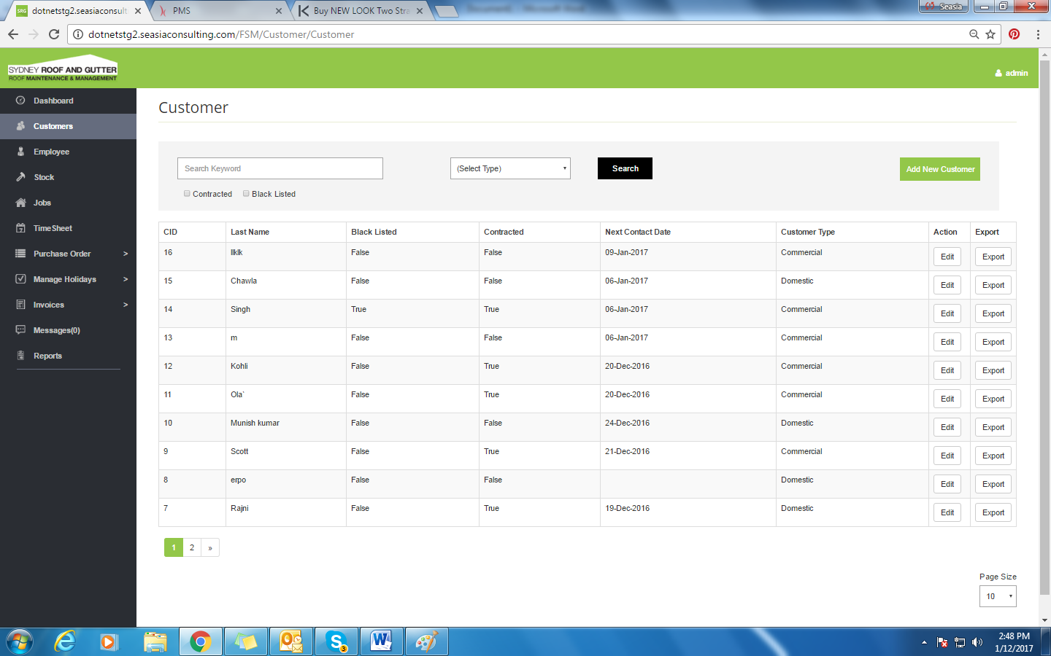

* This screen will display the list of all customers.
* Search option to search any customer accordingly.
* Clicking on the column name will sort the grid
* Edit Button to edit any existing customer.
* Delete will delete existing customer.
* User can select page size accordingly.

## Add new customer

On clicking the ‘Add New Customer’ button the screen displayed as below:

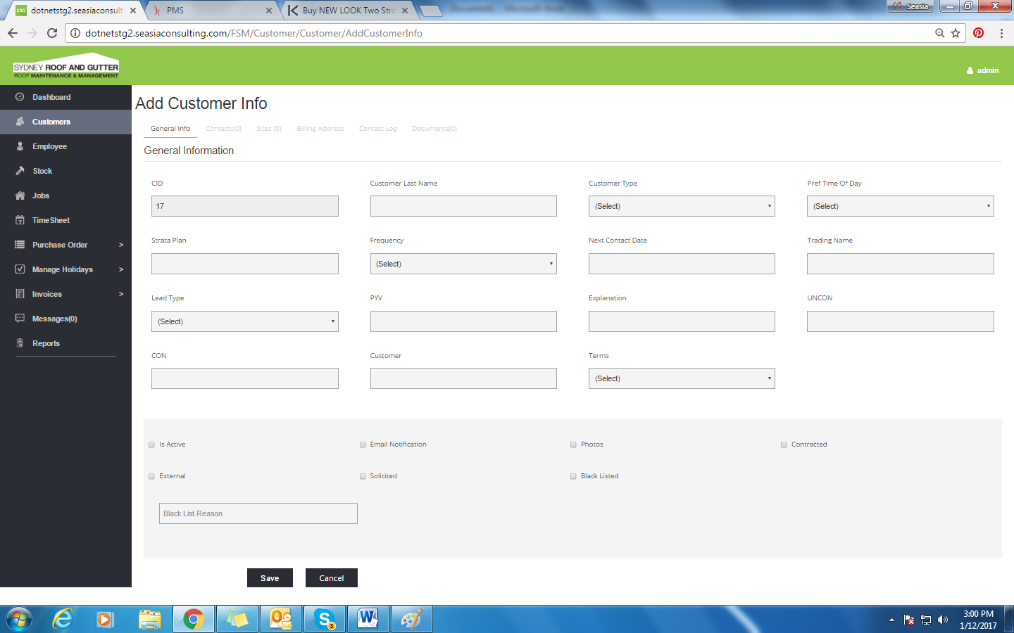

* Adding New Customer will add new customer.
* Different tabs are there to fill up Customer’s information.

## Edit Customer Info

The customer info can be edited by clicking on the ‘edit’ button. The screen displayed is as below:

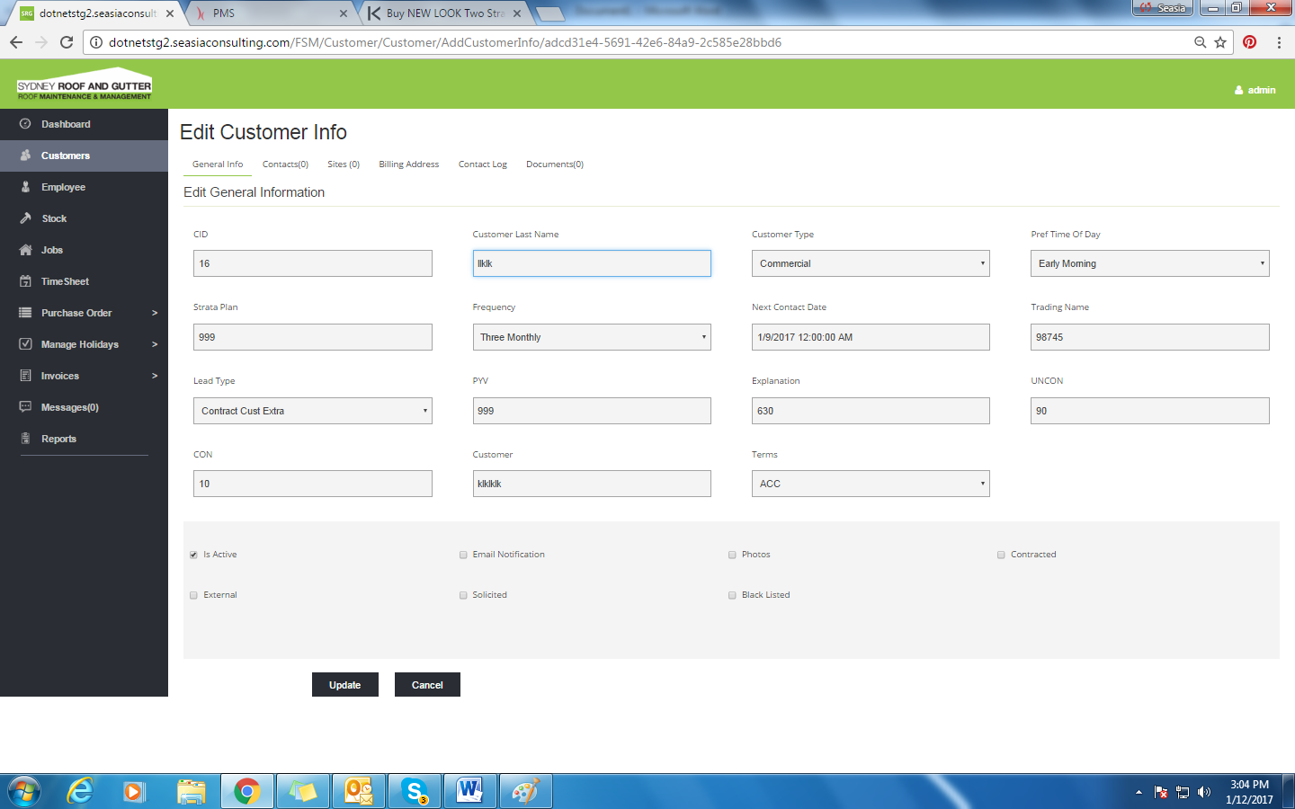

* Editing a customer will update information of existing customer.

# Employee

On clicking the ‘Employee’ option, the screen displayed is as below:

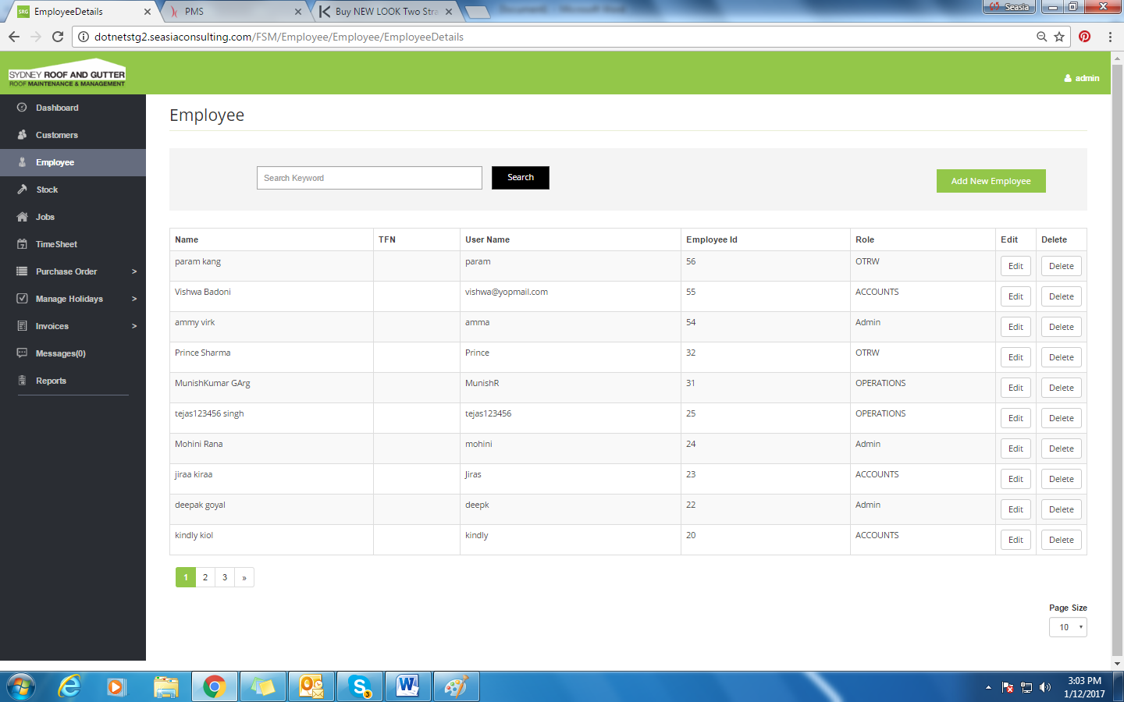

* This screen will display the list of all employees.
* Search option to search any employee accordingly.
* Clicking on the column name will sort the grid.
* Edit Button to edit any existing employee.
* Delete will delete existing employee.
* User can select page size accordingly.

## Edit employee

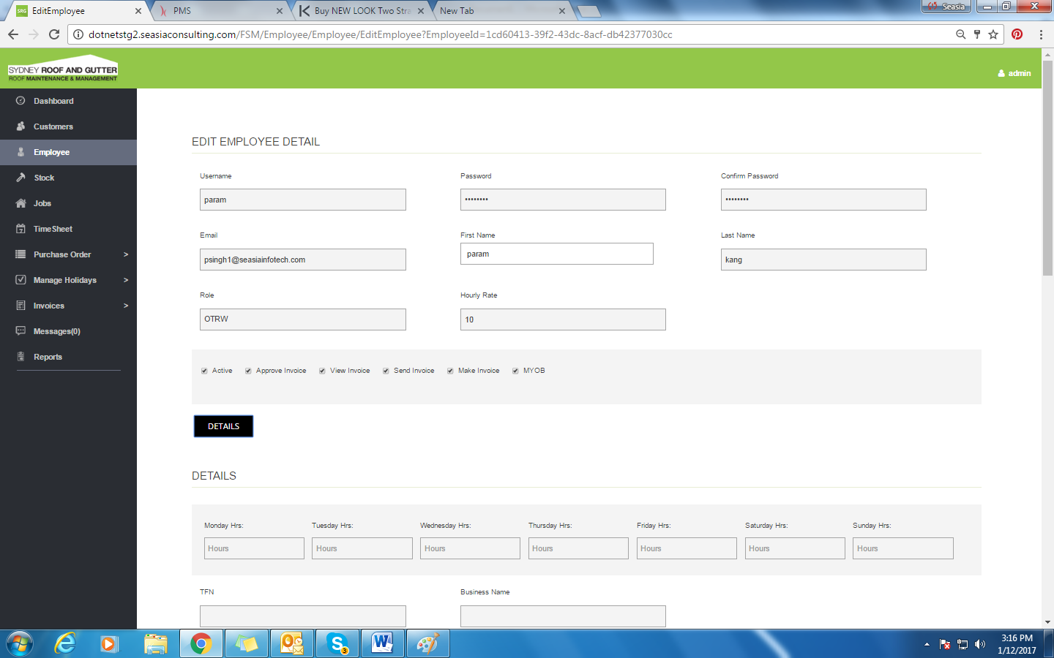

* Editing an employee will update information of existing employee.
* Optional Details can be filled up of employees on clicking Details.

## Add New Employee

On clicking the ‘Add New Employee’ button

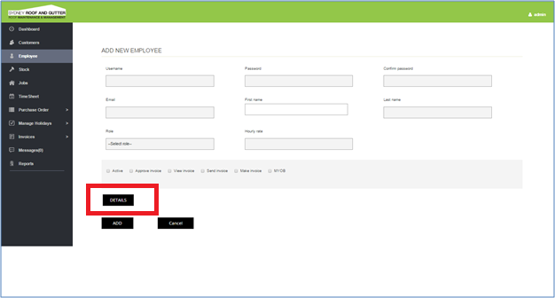

## Details

Clicking on the ‘Details’ button from the Add new employee (above) screen, the form expands which is displayed as below:

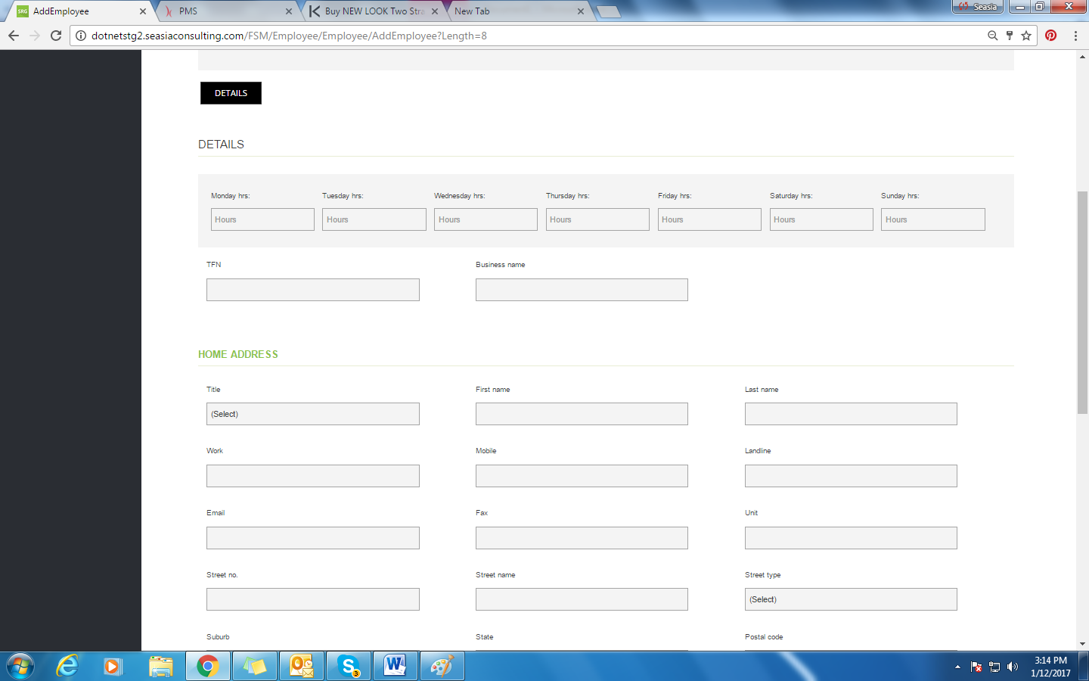

* Details allows user to fill up additional information of employee.

# Stock

On clicking the ‘Stock option, the screen displayed is as below:

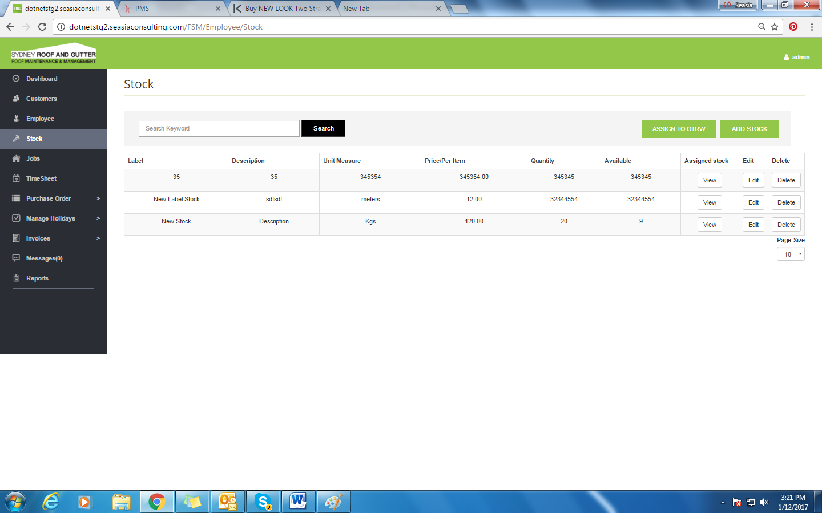

* This screen will display the list of all Stock.
* Search option to search any Stocks accordingly.
* Clicking on the column name will sort the grid.
* Edit Button to edit any existing Stock.
* Delete will delete existing Stock.
* View Button will show the stock details.
* User can select page size accordingly.
* ‘Assign To OTRW’ will assign Stocks to OTRW users.

## View Stock

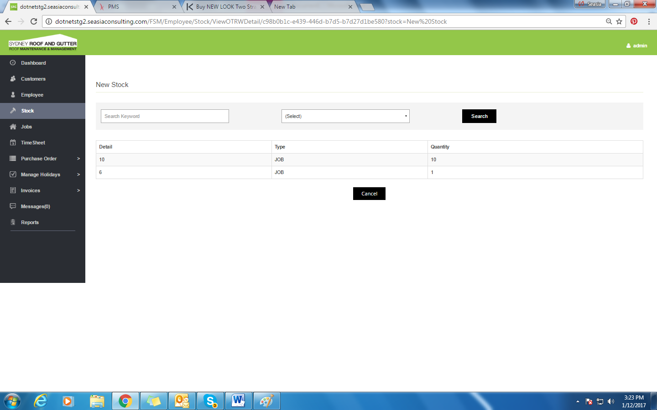

* View stock will show the details of the stock.

## Edit Stock

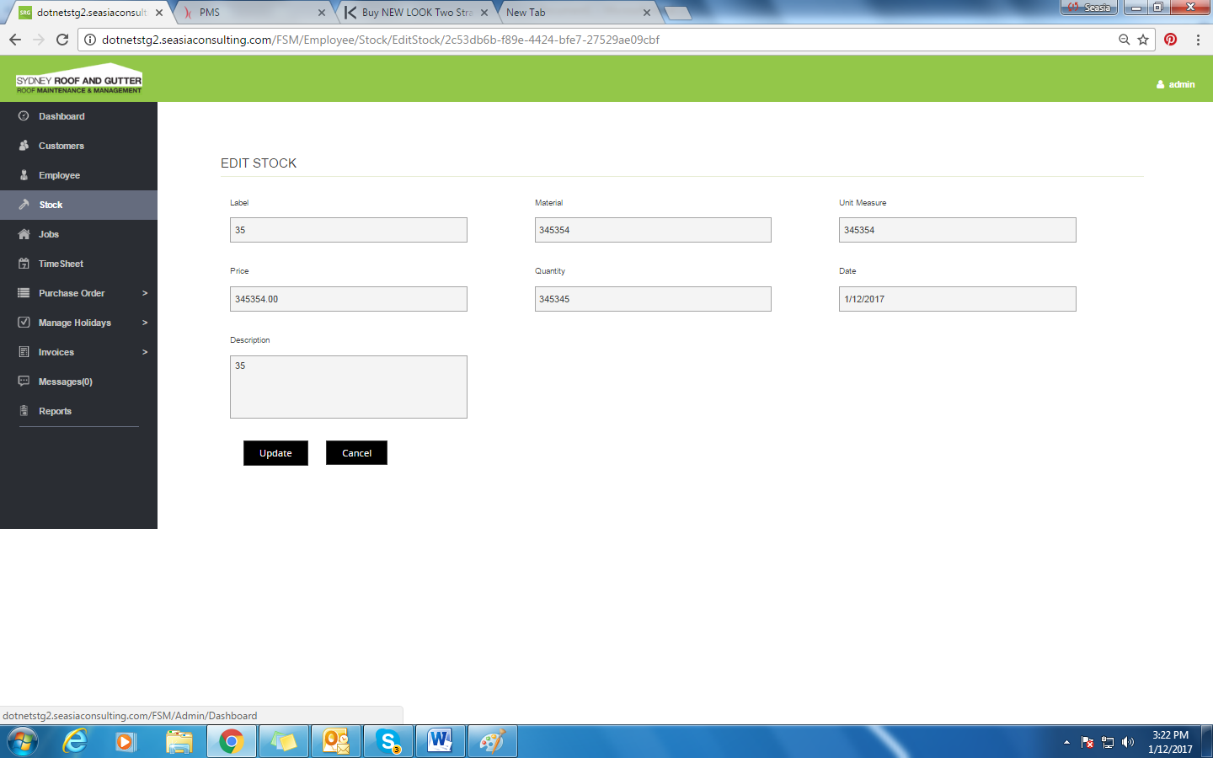

* Editing stock will update the existing stock.

## Assign to OTRW

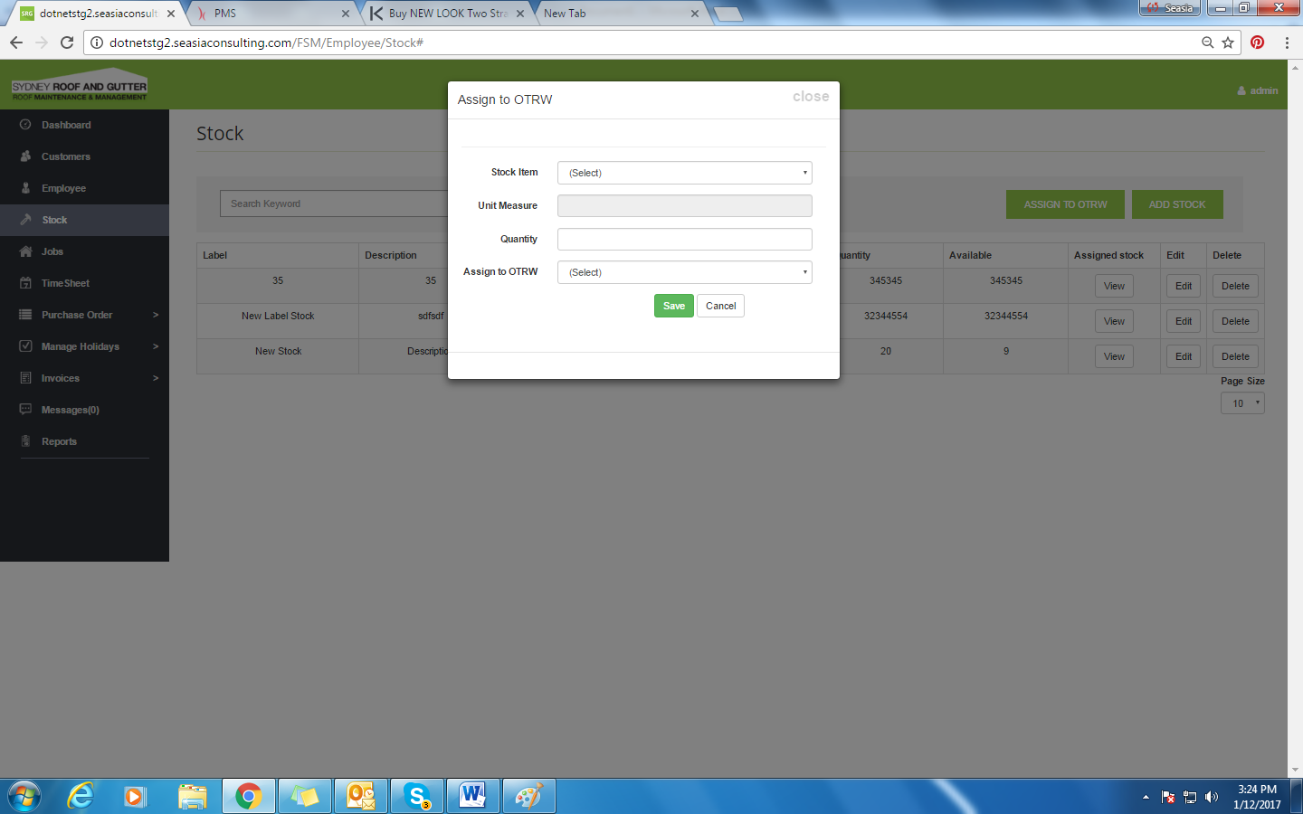

* User can assign stock to OTRW user.

## Add Stock

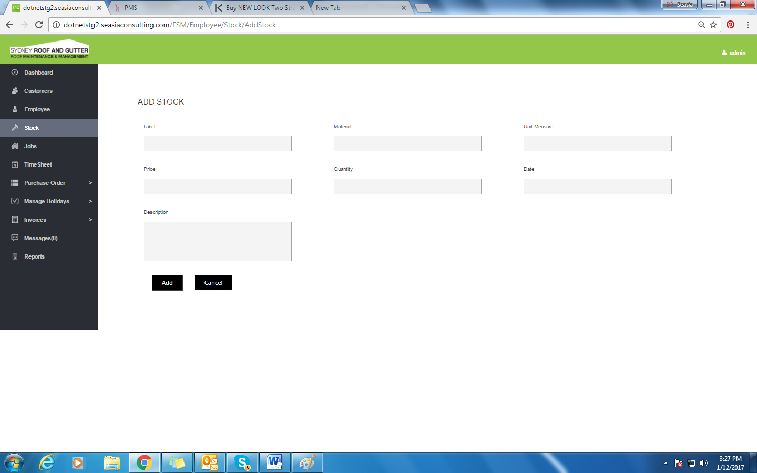

* User can add stock on the click of add stock.

# Jobs

On the click of ‘Jobs’ option. The screen is displayed as below:

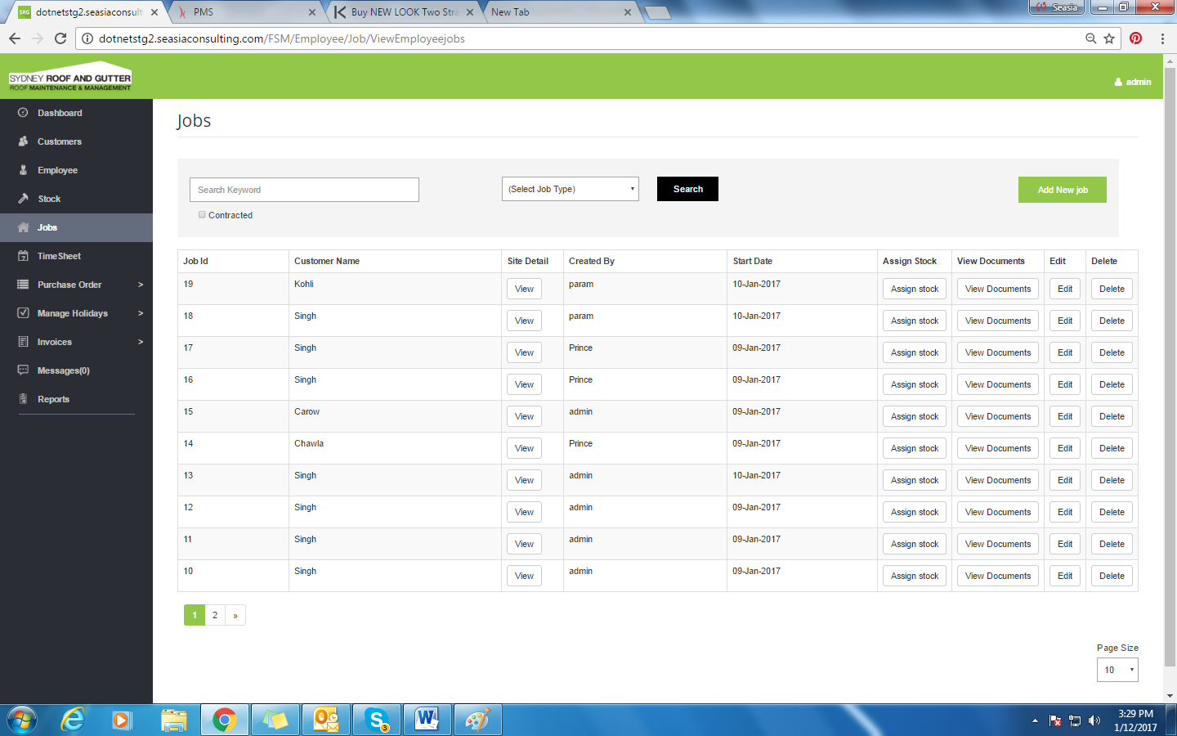

* This screen will display the list of all jobs.
* Search option to search any jobs accordingly.
* Clicking on the column name will sort the grid.
* Edit Button to edit any existing jobs.
* Delete will delete existing jobs.
* View Button will show the jobs details.
* User can select page size accordingly.

## View (Site Detail)

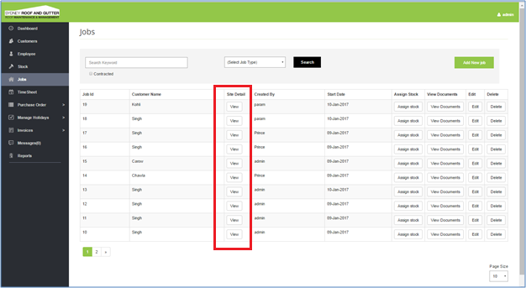

* Viewing Site Detail will display the customer sites detail. The screen will display as below:

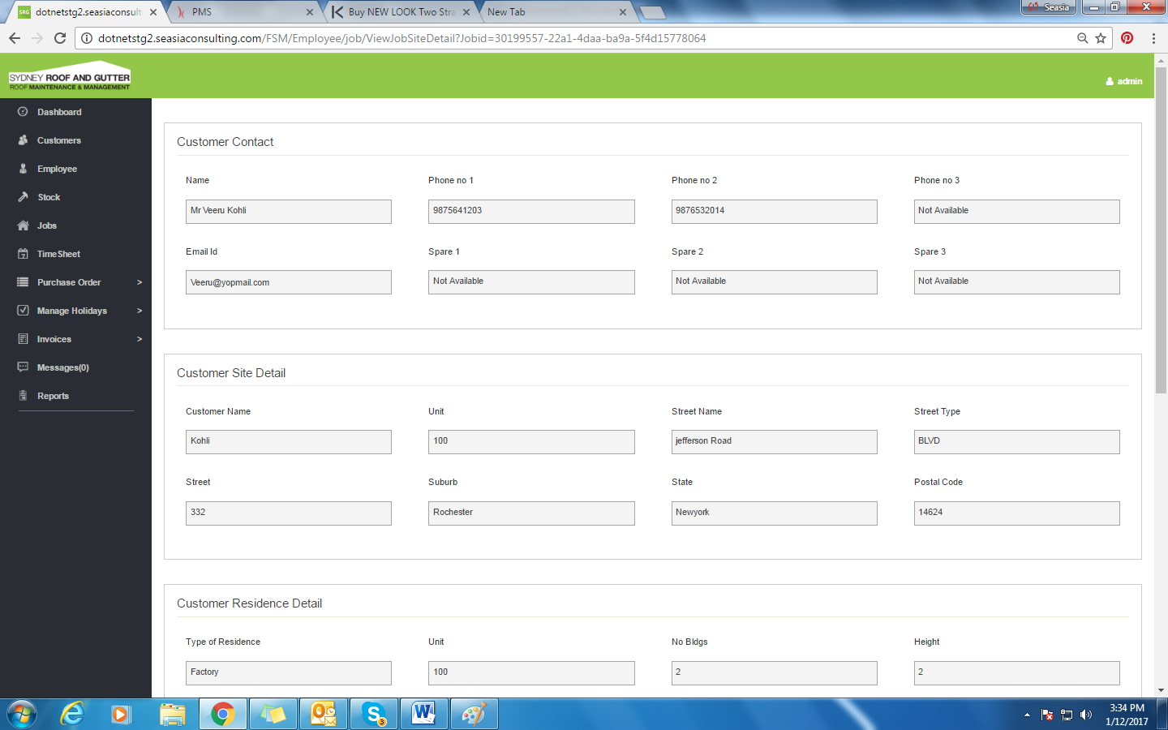

* User cannot update this information from here.

## Assign Stock

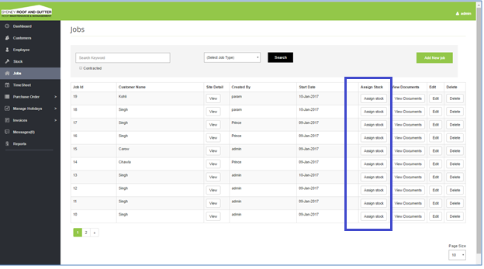

On clicking the **‘Assign stock’** button, below screen will be displayed:

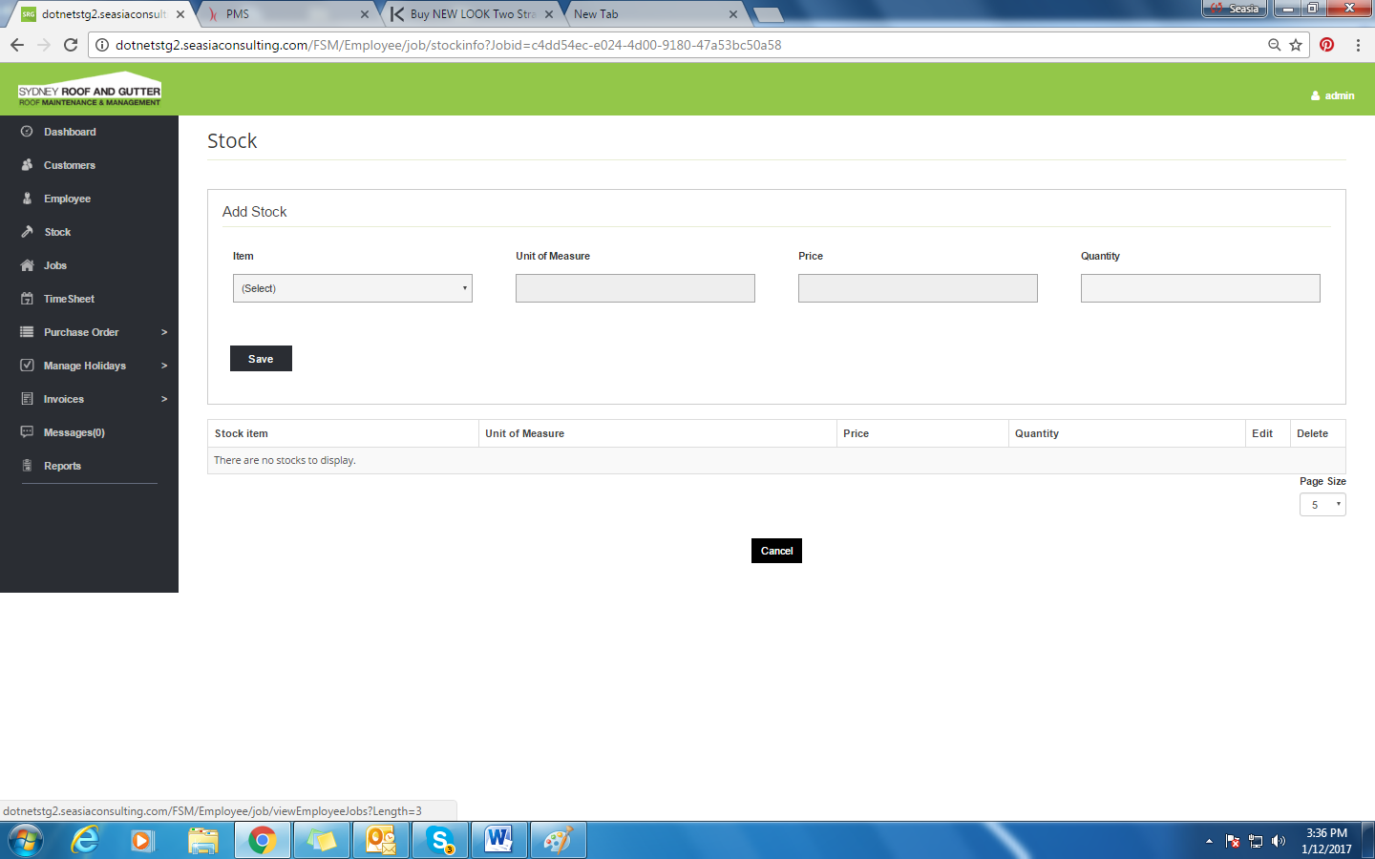

* For the particular job, if stock is not assigned then stock can be assigned here.

## View Documents

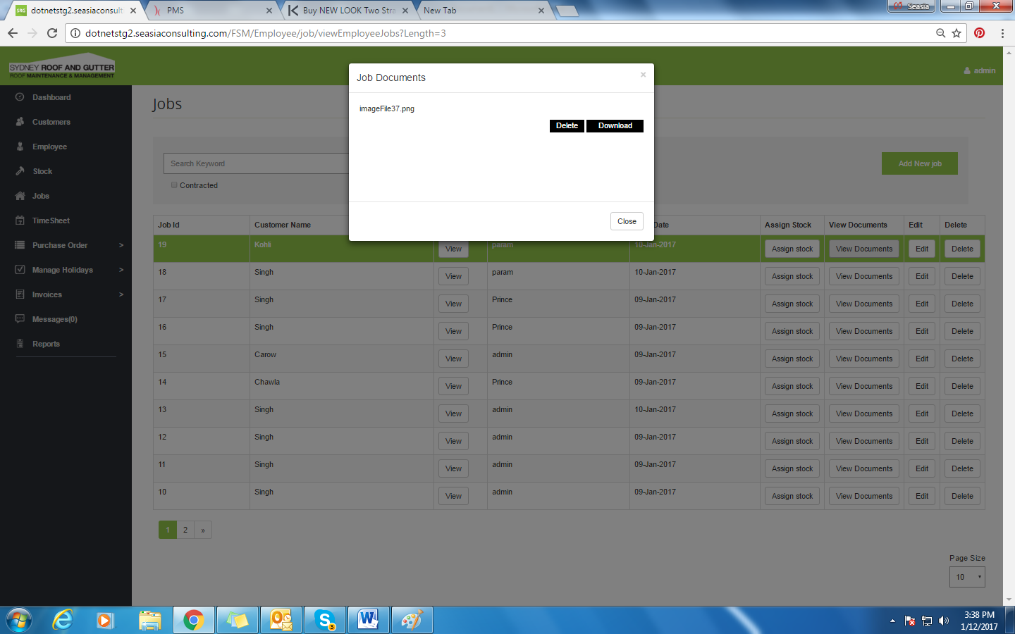

* Documents regarding the particular jobs will be shown here. User can also download the document.

## Add New Job

On clicking the **‘Add New Job’** button, the below screen will be displayed:

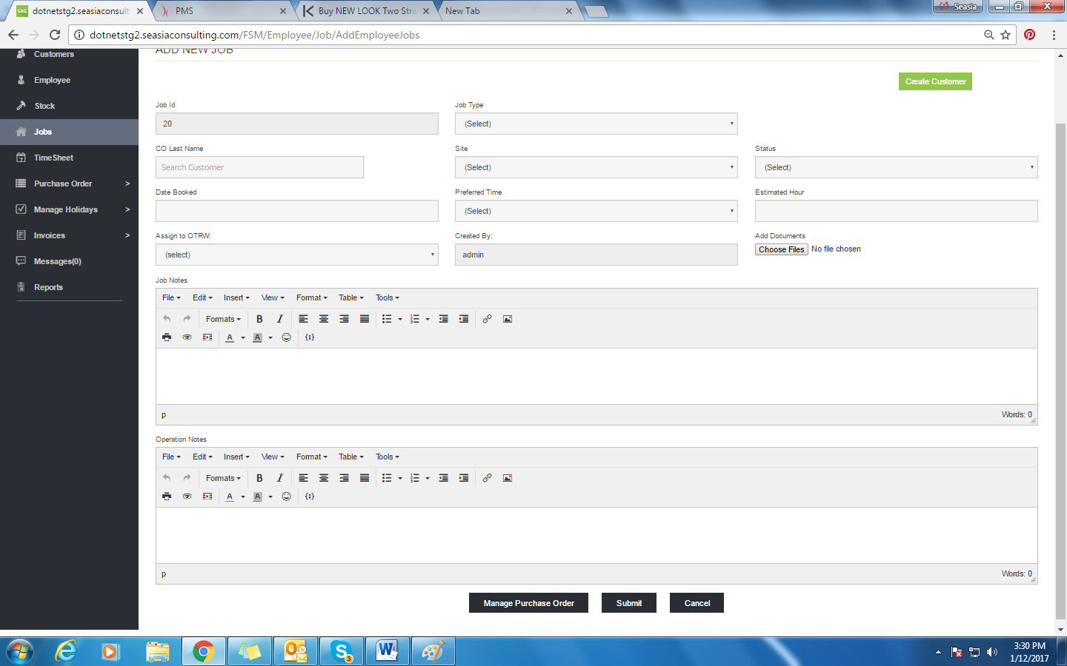

* JobId is auto generated.
* All the details regarding the job will be filled with assigned customer, his site, all the documents and estimated hours to do the job, status of job etc.
* User can also add purchase orders required for the jobs.
* User can link job in case of support job type.

### Manage Purchase order

The screen is displayed as below:

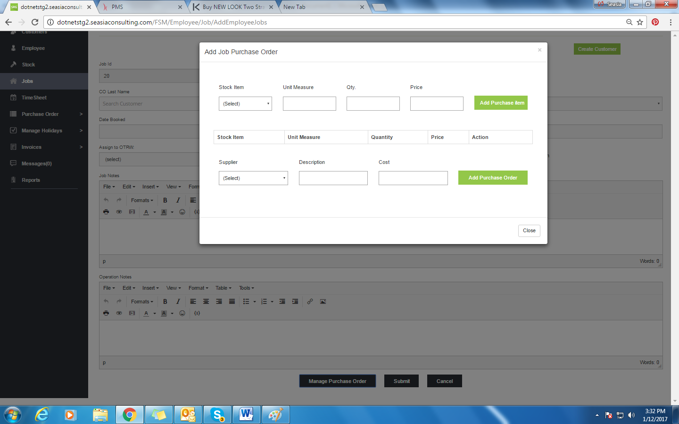

* Purchase Order Screen will add purchase orders regarding the job. Required stocks can be ordered while adding jobs.

# Timesheet

The screen is displayed as below:

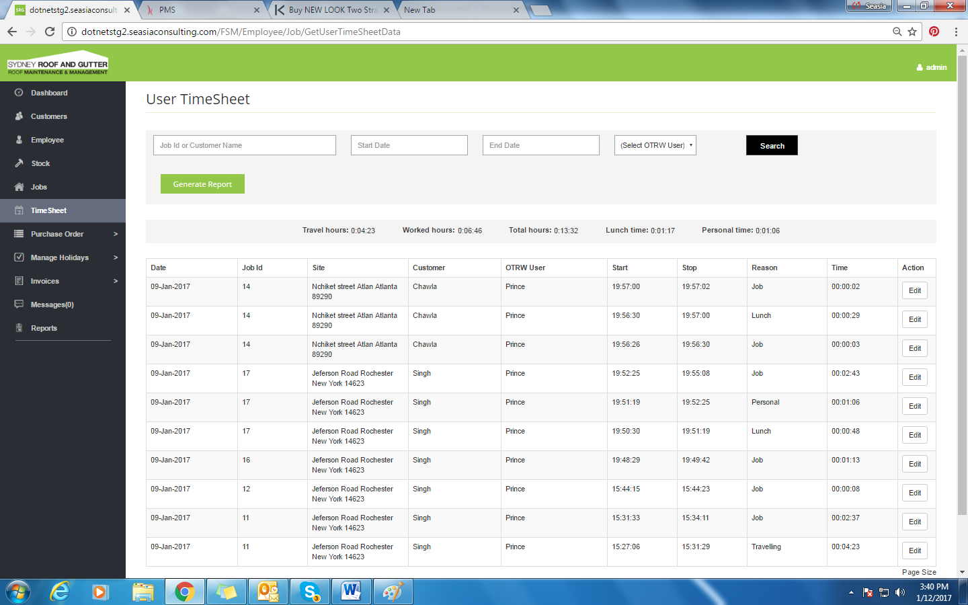

* This screen will display the list of all jobs with specified time.
* Search option to search any jobs accordingly.
* Clicking on the column name will sort the grid.
* Edit Button to edit any existing job timings.
* User can select page size accordingly.

## Edit

On clicking the ‘Edit’ button from Timesheet screen, the user is displayed with the below screen:

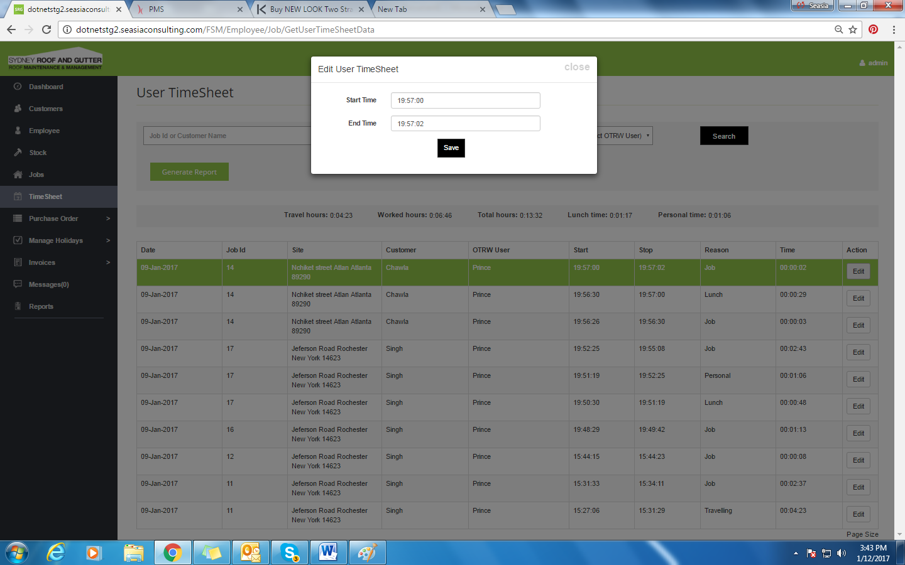

User can edit the Start and Stop timings of Jobs.

## Generate Report

On clicking the ‘Generate Report’ button, report is generated in the pdf format which is displayed as below:

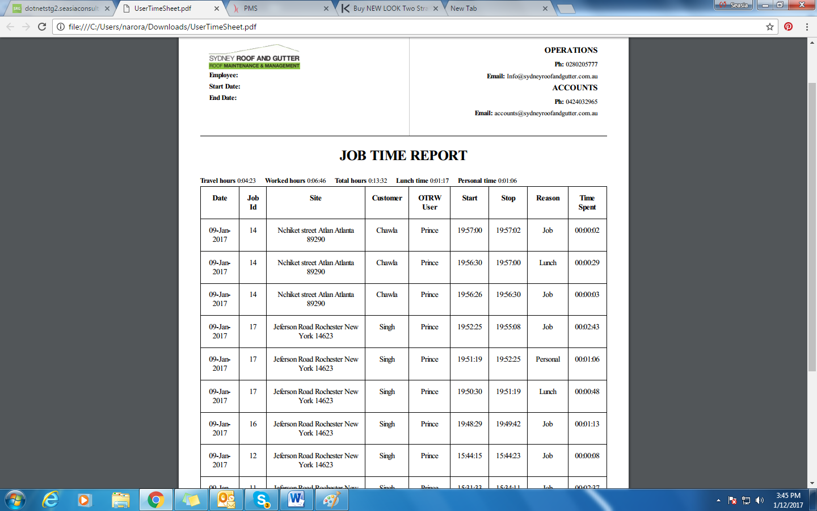

* Generating Report will download all the jobs Listing Timesheet in PDF format.
* All the Jobs that will show in listing will be downloaded.

# Purchase Order

The following are sub-options for purchase order:

* Stock Purchase Order
* Job Purchase Order

## Stock Purchase Order

On Clicking ‘Purchase Order’ option from the side menu, the screen displayed is as below:

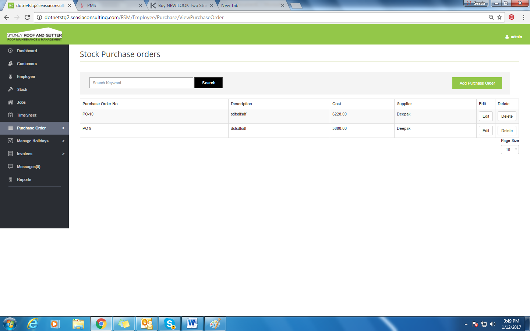

### Add Purchase Order

On clicking **‘Add Purchase Order’** button from the PO screen, the user navigates to the below screen:

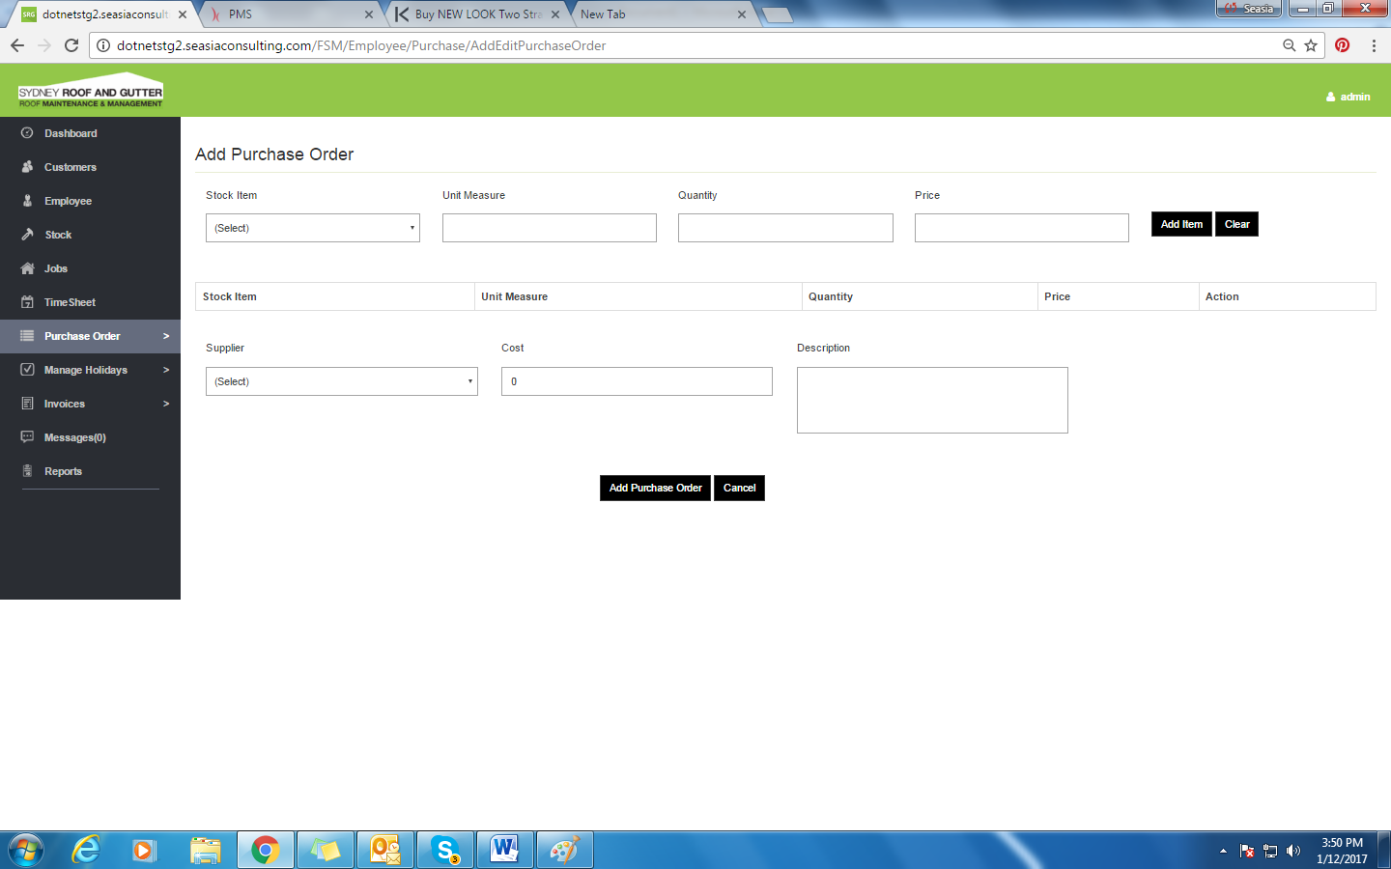

* From this user can add purchase order for his stock.

## Job Purchase Order

On selecting ‘Job PO’ option, the screen is displayed as below:

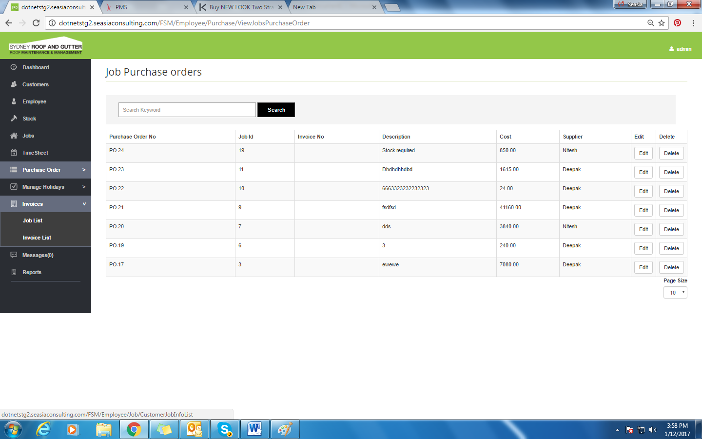

* In this screen only that purchase order will show which created for the job.

# Manage Holidays

The following are the sub-options:

* Employee Holidays
* Public Holidays

On selecting ‘Manage Holidays’ option from the side menu, the screen displayed is as below:

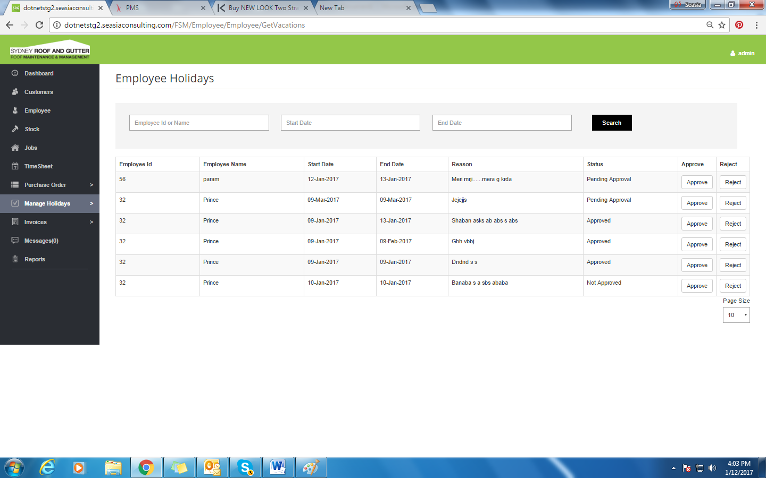

* This screen will display the list of all holidays of OTRW employees.
* Search option to search any holidays accordingly to the employee name, applied holiday start date or end date.
* Clicking on the column name will sort the grid.
* Approved will approve the applied holiday.
* Reject will reject applied holiday.
* User can select page size accordingly.

## Public Holidays

The screen displayed is as below:

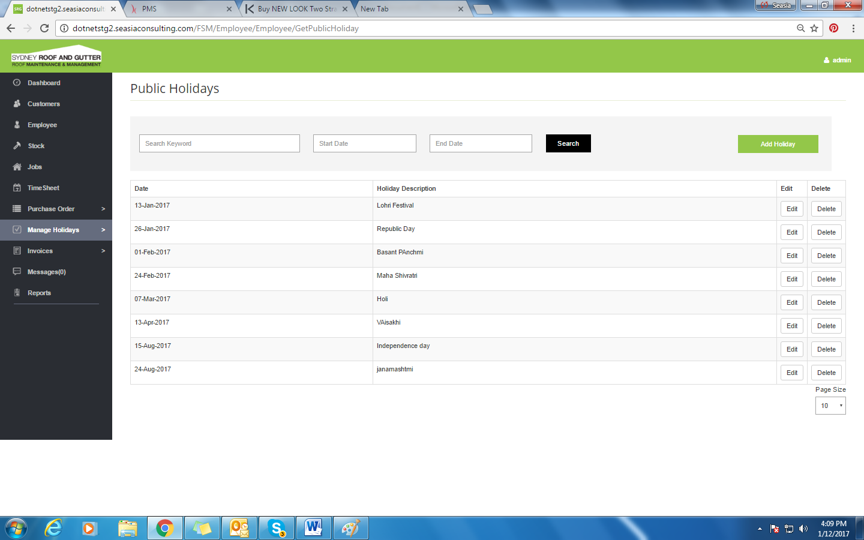

* This screen will display the list of all public holidays.
* Search option to search any holidays accordingly to holiday description, holiday start date or end date.
* Clicking on the column name will sort the grid.
* Edit will update the existing holiday
* Delete will delete the existing holiday.
* User can select page size accordingly.

### Add Holiday

On clicking ‘Add Holiday’ button, a pop-up is displayed as below:

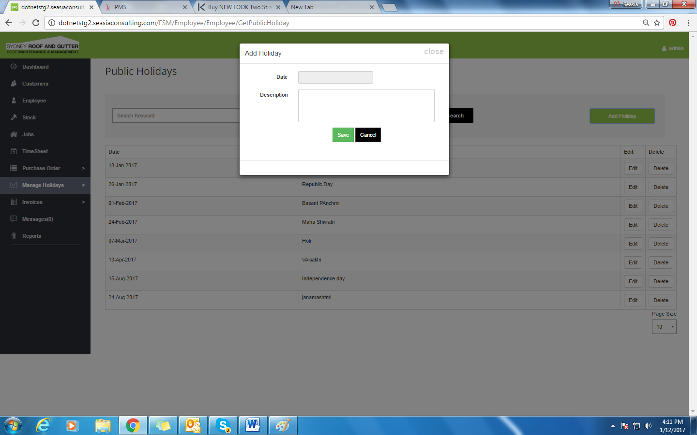

* To add holiday, Add holiday POP Up will be displayed, holiday can be added with the date and description.

# Invoice

The following are the two sub-options:

* Job List
* Invoice List

## Job List

The screen is displayed as below:

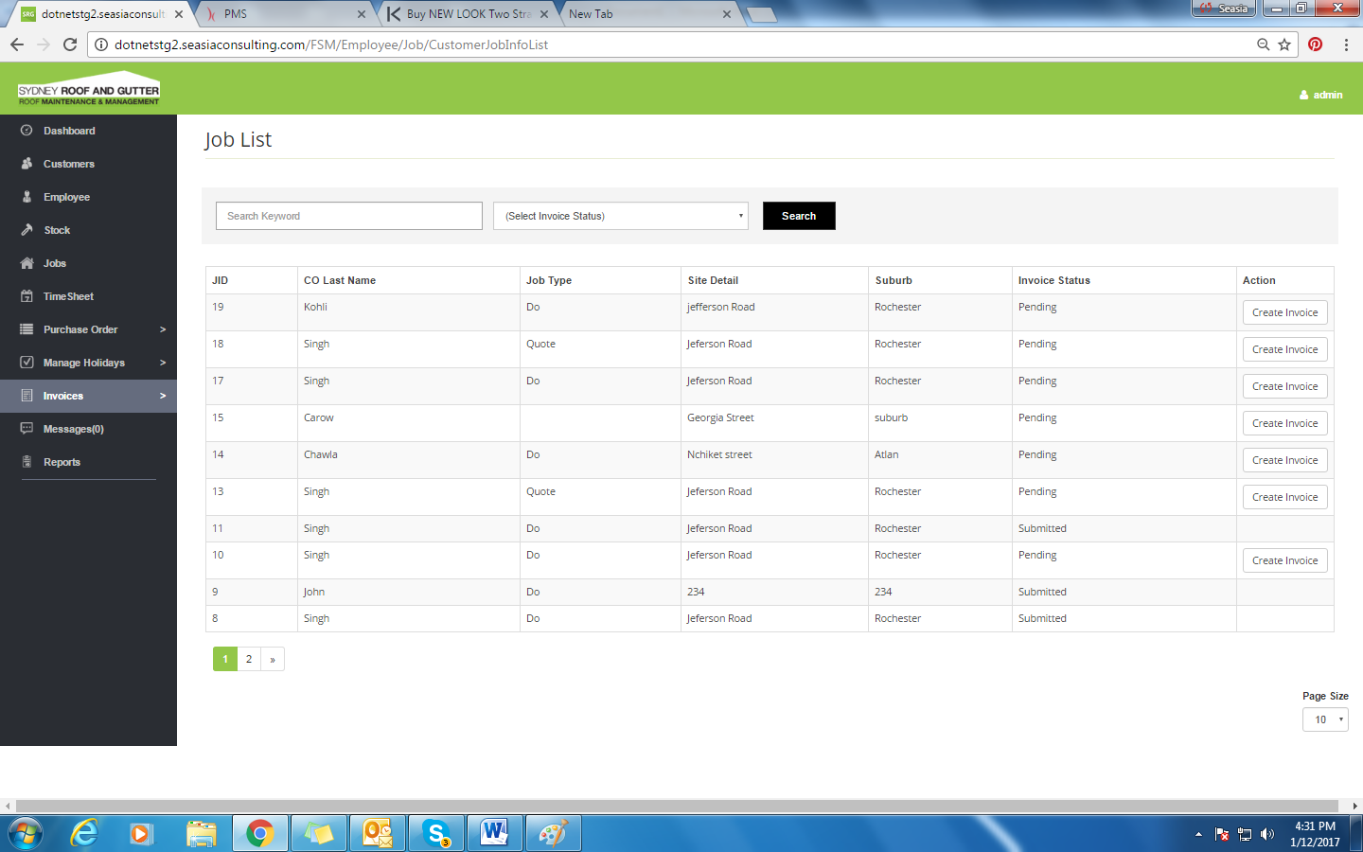

* This screen will display the list of all Jobs for Invoices according to the status “Pending or Submitted”.
* Jobs with pending status mean Invoice is not created yet for this job. When job will be done, Invoice would be created.
* Jobs with submitted status means, Job is done and its invoice is created according to the job.
* Search option to search any jobs accordingly with the filter of status “Pending or Submitted”.
* Clicking on the column name will sort the grid.
* User can select page size accordingly.

### Create Invoice

On clicking ‘Create Invoice’ button, the screen is displayed as below:

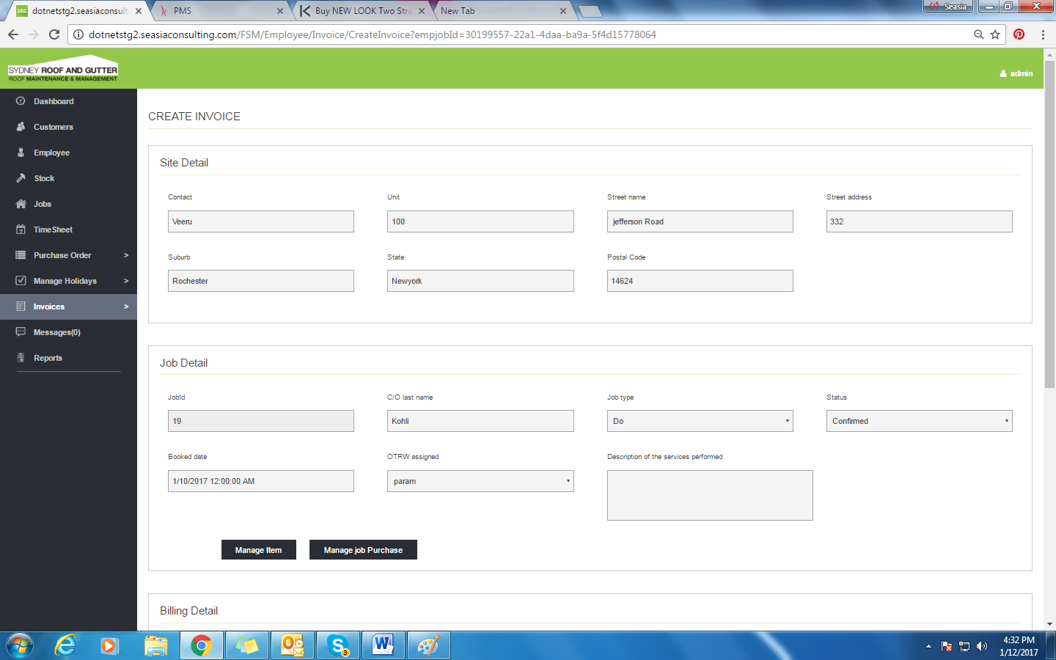

* When job will be done, invoice will be create corresponding to the job done.
* All the details of the jobs will be filled up such as site detail, Job details, all the billing details and also invoice details.
* User can edit the details here for the invoice.

### Manage Item

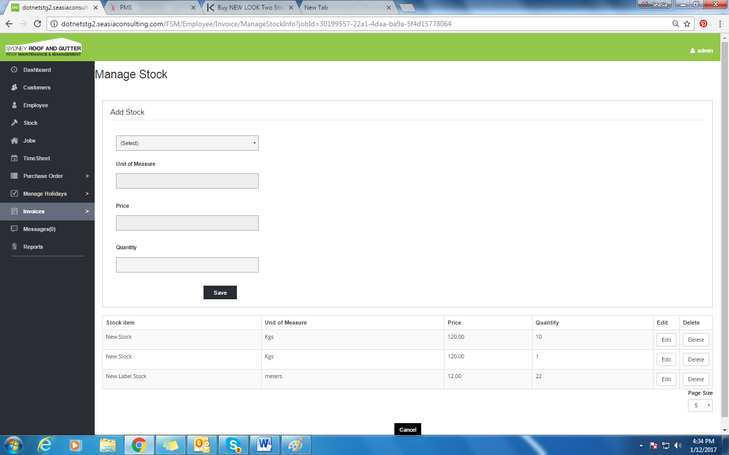

* Here user can see the items which are assigned to this job. User can add and delete items from here also.

### Manage Job Purchase

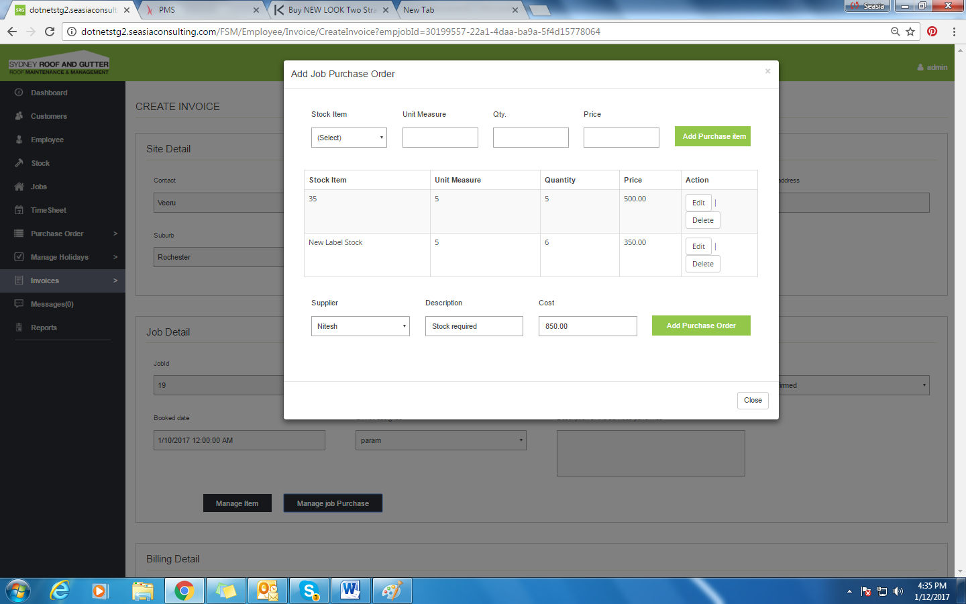

* User can see items of the purchase orders here which are linked with job.
* User can add or delete item from the purchase order from this screen.

## Invoice List

The screen is displayed as below:

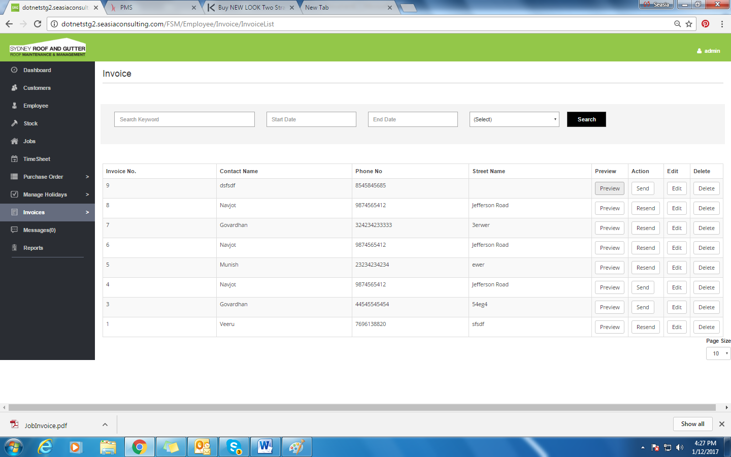

* Invoice list will show list of all invoices created.
* Preview will show the PDF format of invoice which is created.
* User can preview and recheck the invoice details.
* Send button will Send invoice to the concerned customers mail.
* Edit will allow user to edit already created invoice.

### Preview

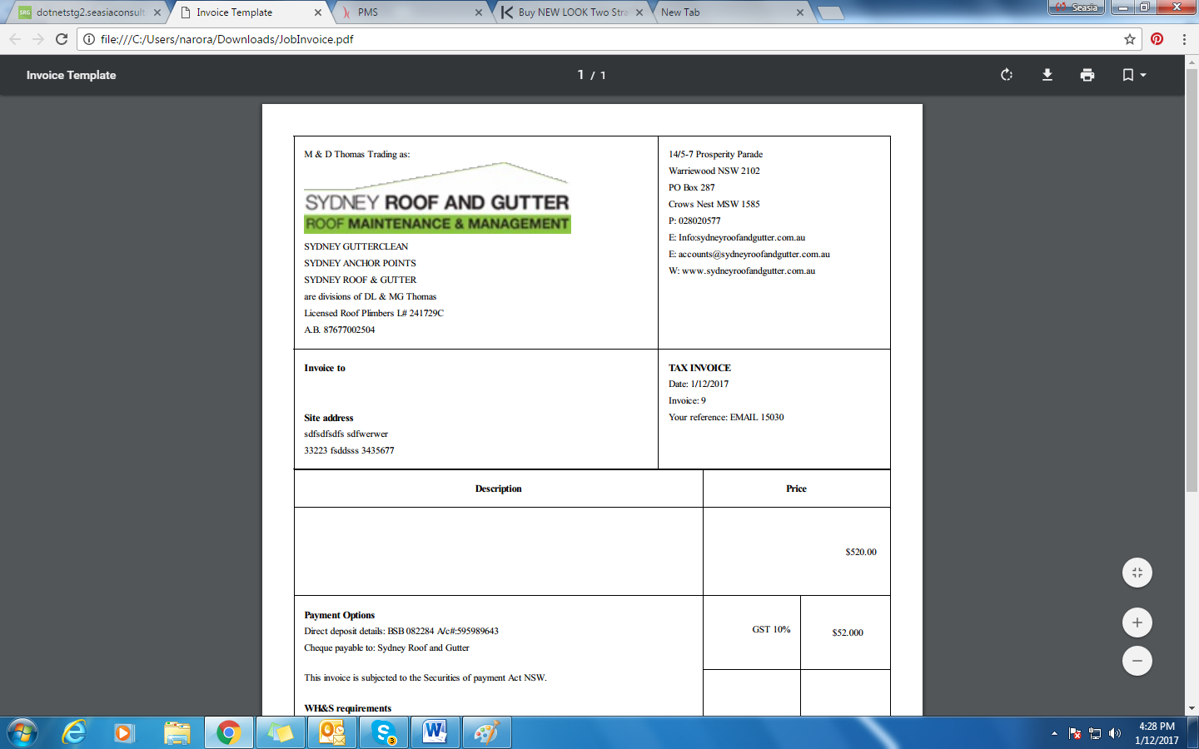

* Preview will display the Invoice in PDF format.
* It will show the Invoice Details such as Address , Bill amount, tax for the same.

### Send

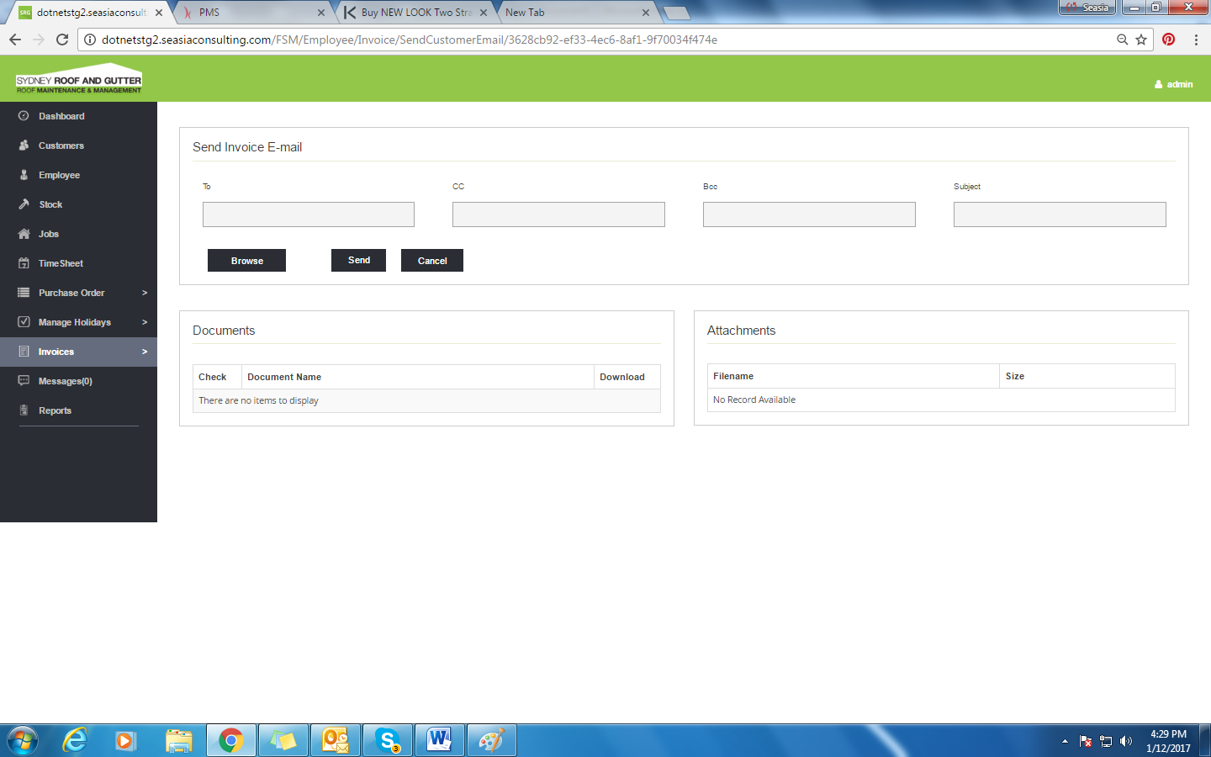

* Send Invoice will display the screen and it will send the e-mail to the concerned job customer.
* All job related documents will display here by default. User can attach more files here.

# Messages

On selecting ‘Messages’ option from the side menu, screen is displayed as below:

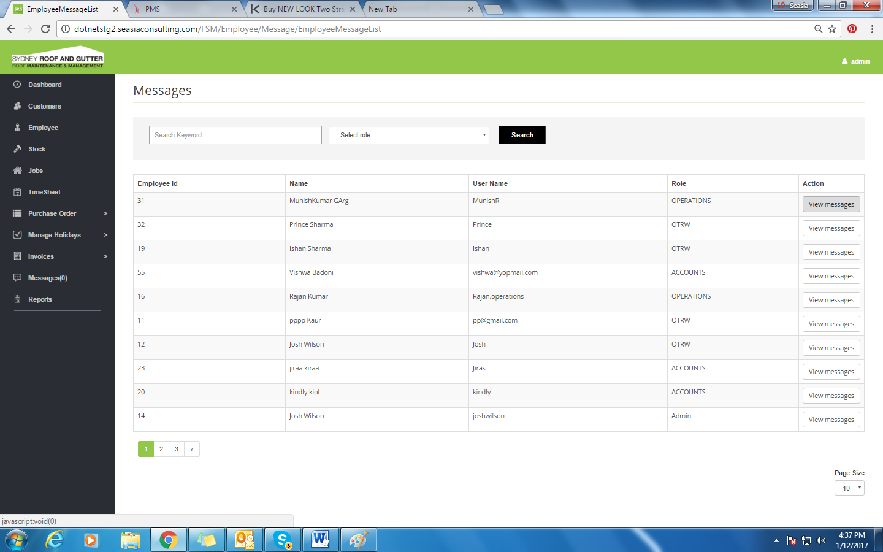

* View Messages will allow user to chat with the Employee. It is service based not real time.
* User can search employees by employee name or its role.

## View Message

On clicking the ‘View Message’ option from the Message screen, pop-up displayed as below:

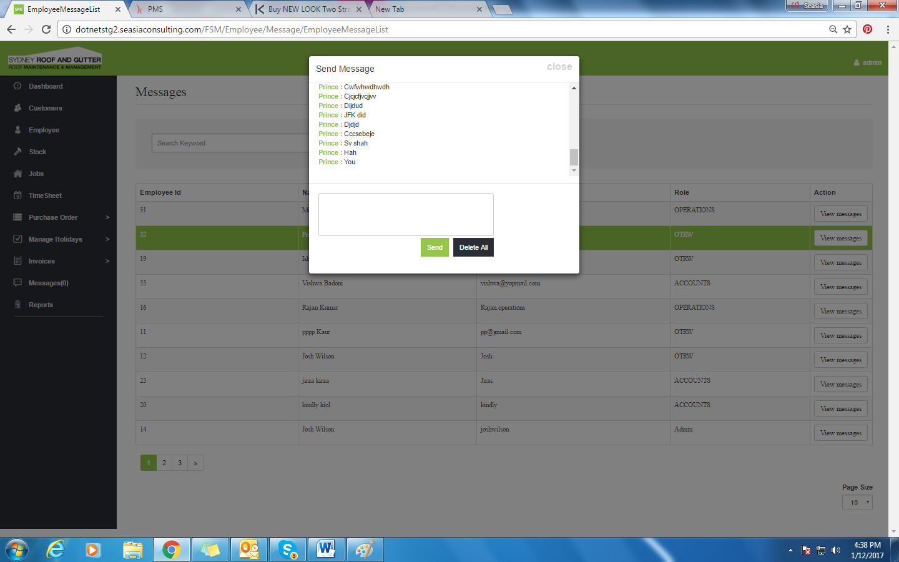

* All the recent chats will be shown here.